HCL INTERNSHIP-MINI PROJECT

A.GNANA SAGAR

39110057

19S115016

Tittle:

CAR PRICE PREDICATION APPLICATION

Car price prediction using machine learning, which predicts the price of used cars which are also called as second hand cars. And this project also has some GUI screens to take the inputs and display the outputs.

Features:

• Select the company

• Select the model

• Select year of purchase

• Select the fuel type

• Enter the number of kilometres that car has travelled

• Predict price

**Language used:**

• Python

• html

• css,flask

**SCOPE:**

Using the basic parameter such as car name,Brand name,year of purchase, fuel type ,kilometers driven to predict

Car price which the owner can except when the condition of car is perfect and after that Price may be decrease due to other factors

**ABSTRACT:**

The price of a new car in the industry is fixed by the manufacturer with some additional costs incurred by the Government in the form of taxes. So, customers buying a new car can be assured of the money they invest to be worthy. But, due to the increased prices of new cars and the financial incapability of the customers to buy them, Used Car sales are on a global increase. Therefore, there is an urgent need for a Used Car Price Prediction system which effectively determines the worthiness of the car using a variety of features. Existing System includes a process where a seller decides a price randomly and buyer has no idea about the car and it’s value in the present day scenario. In fact, seller also has no idea about the car’s existing value or the price he should be selling the car at. To overcome this problem we have developed a model which will be highly effective. Regression Algorithms are used because they provide us with continuous value as an output and not a categorized value. Because of which it will be possible to predict the actual price a car rather than the price range of a car. User Interface has also been developed which acquires input from any user and displays the Price of a car according to user’s inputs.

**FLOW DIAGRAM:**

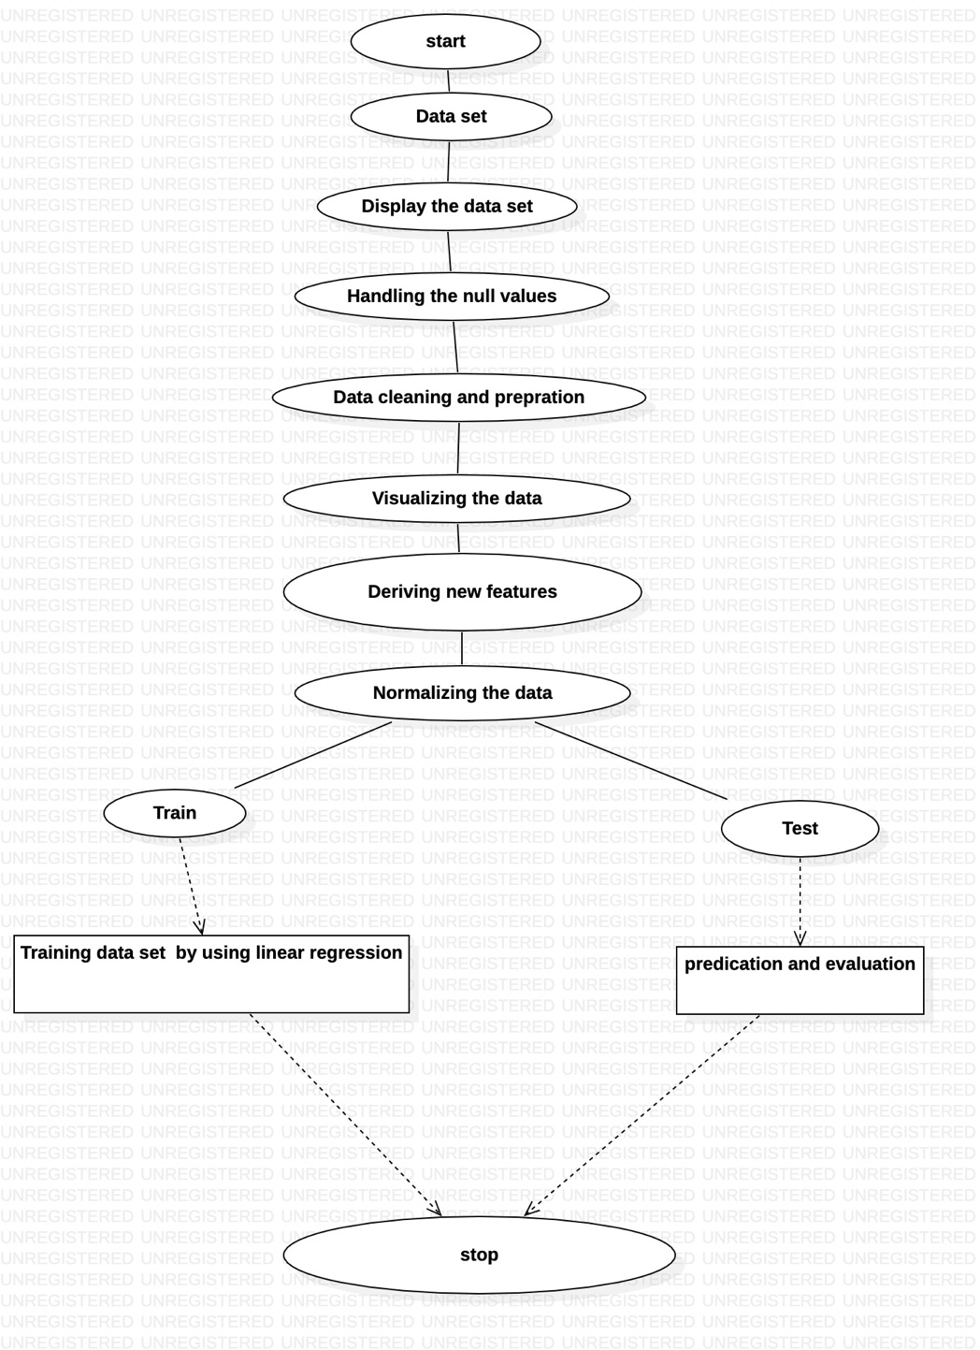

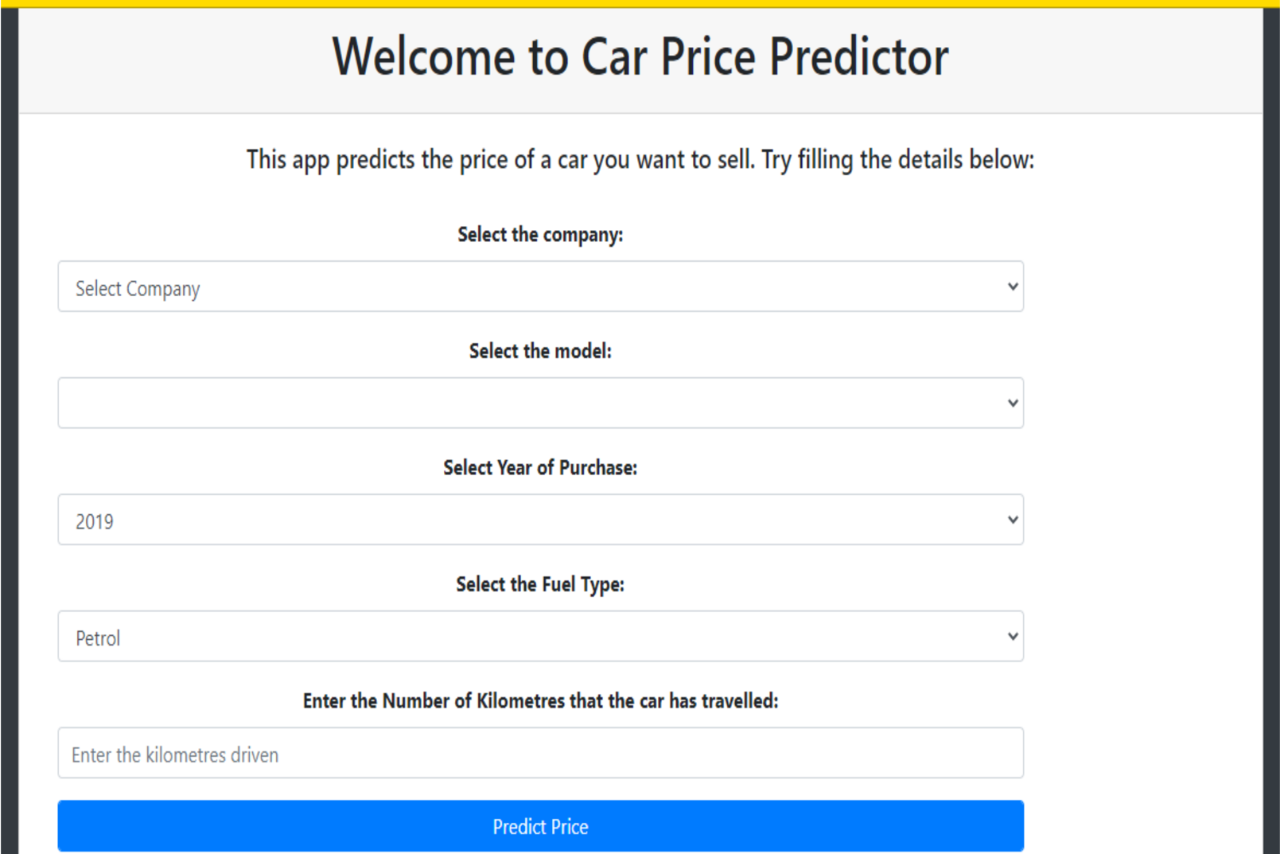

**GITHUB LINK: https://github.com/Amujuru1**